

**SANYO SN-58CA32 2 Ton**

**Rs. 148,200/-**

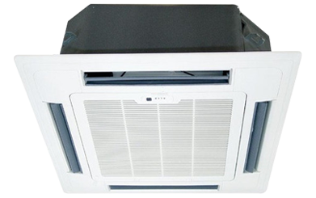

**Product Features**

* Independent Dehumidification
* Low Noise Air Flow System
* Easy Clean Panel
* Remote Control Pocket
* Three Minutes Protection

**Specification**

**Type** Ceiling Cassette AC

**Cooling (Btu/h)** 51000

**Voltage (V)** 220-240

**Power Input (W)** 4600

**EER (Btu/W-h-W/W)** 7.7-3.5